Case Study – Cryo Body Sculpting

User - Laura Davies FDSC

**OBJECTIVE.**

The objective of the trial was to evaluate the effectiveness of the TruCryo KaasenLife device to stimulate localised thermal shock in order to achieve inch-loss around the waistline in a variety of clients.

**SCIENTIFIC BASIS.**

The latest scientific research into cryo-stimulation and cold stress (thermal shock) suggests it provides multiple beneficial effects on the human body. From the perspective of this trial, we were most interested in the following processes and outcomes;

• Cryo-lipolysis - the permanent destruction of fat cells, which are then flushed through the lymphatic system

• Increased browning of adipose tissue (fat cells); a process which makes the fat cells metabolise more efficiently and so fat-loss occurs more quickly

• Accelerated microcirculation (the smallest blood vessels which supply the skin), which supports better oxygenation of derma cells and encourages collagen production for healthier skin

• Removal of dead skin to stimulate new smoother skin growth

• Causes vasoconstriction and dilation of blood vessels to flush toxins and impurities away

• Increases dopamine which boosts metabolism and energy levels

The KaasenLIfe, cryo Stimulation device causes thermal shock due to its ability to spray CO2 at -78°C, under 50 bar pressure, cooling the targeted treatment area down to 4°C rapidly.

Cryolipolysis is a term used for a treatment using cold temperatures to destroy fat cells by freezing them within the temperature range of +4 to +8°C.

KaasenLIfe causes Thermal Shock by rapid cooling, under pressure achieving precise, optimum conditions for the bodies immune system to respond.

Scientific studies indicate that using Cryo Stimulation induces thermal shock causing Cryolipolysis, destroying fat cells permanently which are then flushed through the lymphatic system. Targeting cold stress directly on fatty areas causes what is known as non-shivering thermogenesis which also increases browning of adipose tissue that boosts metabolism burning off fat and staving off obesity.

**METHOD.**

Eating disorders, body dysmorphia, health, any other mental illness or physical contra-indictaions

The client’s waist was measured at the start of each appointment, prior to commencement of treatment in order to establish a baseline measurement. The area to be treated was assessed for suitability (to ensure there were no open wounds or other trauma). The patient was then positioned comfortably, and the stomach area was exposed for treatment. Some clients preferred to stand, while others lay down in a supine position. The exact posture of the client was not assessed for effectiveness as part of this trial.

The area was cleaned and dried, removing any creams or lotions if present. The abdomen was then sprayed with CO2 in bursts of 90 seconds. The high-pressure black nozzle was used, and the spray was moved steadily across the abdomen to ensure all areas were cooled to achieve thermal shock. The whole stomach and flanks were treated equally on each side.

The distance sensors on the device display the optimum distance for application of the CO2 to ensure the spray is delivered efficiently and effectively and to prevent surface tissue damage.

The skin surface temperature of the area being treated was reduced to around 4OC in around 15 seconds, achieving thermal shock. The area was then sprayed continuously in order to maintain a skin surface temperature (as indicated by the dual temperature sensors) of between 0 and 4oC for the remainder of the 90 seconds. The extended period of cooling enabled the penetration of the cold temperature to the underlying adipose tissue.

The entire target area was sprayed, and the skin surface temperature was maintained at between 0 and 4°C as described above.

Following completion of the 90-second sprays, a 5-minute period was observed to allow the treated areas to return to its normal surface temperature of around 34OC.

A 2-minute light-pressure massage was then applied to aid the process of flushing out the destroyed fat cells through the lymphatic system. No other medication or modality equipment was used as part of the trial.

All clients stated that they had not changed their diet, increased their normal exercise or changed their lifestyle routines during the trial.

The safety and comfort of each client was closely monitored throughout their treatment.

12 patients attended weekly appointments and completed a course of six treatments, once per week over 5 weeks.

**RESULTS.** Between December 2018 and January 2019, 12 clients were treated for using the KaasenLife device. Every patient achieved inch loss around the waist, the minimum centimeter loss around the waste was 5cm and the maximum was 15cm. Most people averaged between 2 – 10cm loss around the waist after just the first session. The treatments were repeated once a week and further toning and inch loss was achieved over the course of five further treatments. (See Pictures) No side effects were reported. All patients reported a feeling of well-being following the procedure and felt they would recommend the KassenLife to friends and family for body sculpting.

**OBSERVATION.** All patients achieved inch loss after just the first treatment.

All Patients also saw a visible firming and tightening of the skin and felt invigorated post treatment.

All patients reported a feeling of well-being following the procedure and felt they would recommend the KassenLife to friends and family for body sculpting.

**CONCLUSION**. Kaasen life cryo stimulation is a targeted, safe, non-pharmacological/non-invasive technique. KassenLife proved that Cryo Stimulation is a very effective application for rapid inch reduction, skin toning and tightening. More studies are currently being carried out to see the long-term results of CryoSculpting. Care should be taken to also look at the patient’s diet and lifestyle which also are very important factors obviously in improving and maintaining the results. The process of using “Kaasen Life” for Fat Freezing was a simple and straight forward procedure.

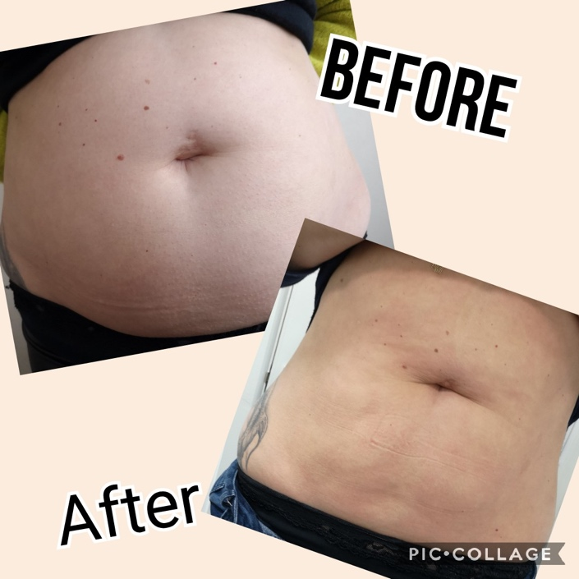 6” loss

